Date | 30September 2026
TeamID | 6ab4dd7a6f290be8a6b49f92
ProjectName | Script-Controlled ACL – Restrict Record Access Based on Field Value
Maximum Marks | 3 Marks

FINAL PROJECT REPORT
Script-Controlled ACL – Restrict Record Access Based on Field Value
ServiceNow Developer Instance
8-Phase Project Submission Report
Project Platform | ServiceNow Developer Instance
Application/Table | Institution Details
Security Mechanism | Access Control Lists (ACLs)
Team | 1 Project Leader + 4 Team Members
Submission Structure | 8 phases + GitHub repository + Google Drive demo video
Submission Alignment
This report is organized to match the required eight-phase project submission structure: Brainstorming & Ideation, Requirement Analysis, Project Design, Project Planning, Project Development, Project Testing, Project Documentation, and Project Demonstration. The GitHub repository is expected to be public and contain the project files phase-wise. The demonstration video is expected to be uploaded to Google Drive with access set to Anyone with the link can view.
Phase | Required Phase | Report Coverage
Phase 1 | Brainstorming & Ideation | Problem identification, ideation and proposed field-based ACL solution.
Phase 2 | Requirement Analysis | Functional, security, platform and data requirements.
Phase 3 | Project Design | Architecture, Use Case, DFD, ER model and ACL design.
Phase 4 | Project Planning | Team responsibilities and seven-day schedule.
Phase 5 | Project Development | ServiceNow configuration, table creation, roles, records and ACL implementation.
Phase 6 | Project Testing | Test cases, validation and screenshot evidence.
Phase 7 | Project Documentation | Final report, user manual, ACL matrix, script and supporting files.
Phase 8 | Project Demonstration | Complete screen-sharing video with explanation, working process and final output.
PHASE 1 – Brainstorming & Ideation
1.1 Project Overview
The project addresses the need to restrict ServiceNow record access according to a field value. The Institution Details table contains records for different branches, and the configured project user must not receive unrestricted access to records outside the authorized EEE branch.
1.2 Problem Statement
Role-based access alone may provide access to an entire table even when a user should only see records belonging to a particular branch. The proposed solution combines roles, ACL conditions and a script-based Branch check to provide record-level security.
Figure 1. Ideation Diagram
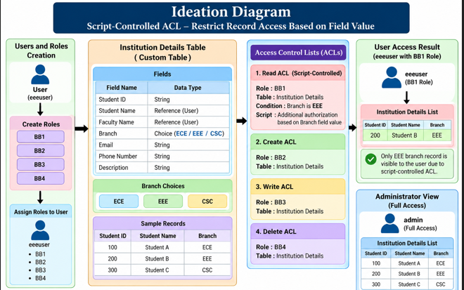

The ideation identifies the main security problem, the Institution Details data source, ACL processing, and the expected authorized/restricted result.
1.3 Objectives
• Create a project user and roles BB1–BB4.
• Create the Institution Details table and required fields.
• Configure ECE, EEE and CSC branch choices.
• Implement Read, Create, Write and Delete ACLs.
• Restrict Read access using the Branch value and authorization script.
• Test and document the complete project.
PHASE 2 – Requirement Analysis
2.1 Functional Requirements
• User creation and role assignment.
• Institution Details table creation.
• Branch choice configuration for ECE, EEE and CSC.
• Sample record creation.
• ACL configuration for Read, Create, Write and Delete.
• Validation of authorized and restricted access.
2.2 Data Requirements
Field | Requirement
Student ID | String
Student Name | Reference
Faculty Name | Reference
Branch | Choice: ECE, EEE, CSC
Email | String
Phone Number | String
Description | String
2.3 Security Requirements
BB1 controls Read, BB2 controls Create, BB3 controls Write, and BB4 controls Delete. The Read ACL additionally applies the EEE Branch condition and script-controlled authorization.
PHASE 3 – Project Design
3.1 Architecture
The design connects users and roles to ACL processing, the Institution Details table and the resulting access decision.
Figure 2. System Architecture
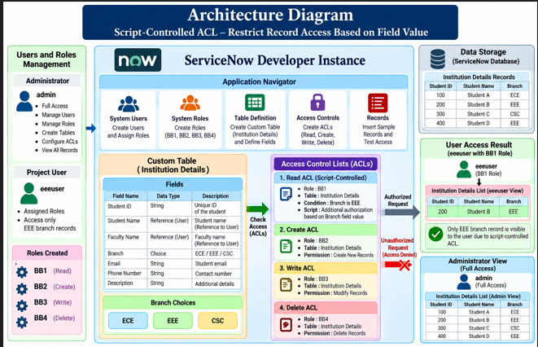

The architecture shows the user/role layer, ACL layer, Institution Details data, branch-based authorization and authorized versus restricted results.
3.2 Use Case
The Administrator configures the application and security rules; the Project User accesses records according to the configured roles and ACL rules.

Figure 3. Use Case Diagram
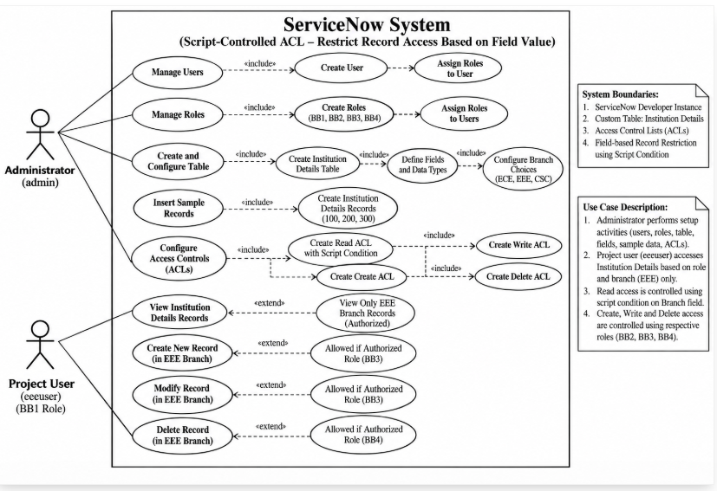

The use cases cover user/role management, table configuration, ACL configuration, record access and the final authorization decision.
3.3 Data Flow Diagram
The data flow begins with configuration and user access, passes through ACL evaluation, and ends with an authorized or restricted record response.

Figure 4. Data Flow Diagram (DFD)
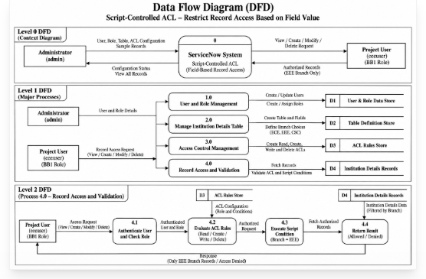

The DFD represents the flow from users and administrators through ServiceNow processes, ACL evaluation and record-level access results.
3.4 ER Diagram
The logical data model centers on Institution Details and relates user/role information to branch-based record security.
Figure 5. ER Diagram

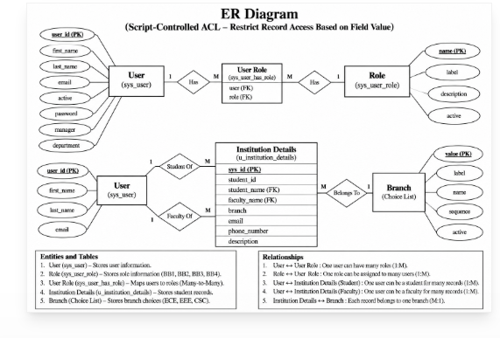

The ER model identifies the principal data entities and relationships used to support the Institution Details application and access-control design.
PHASE 4 – Project Planning
4.1 Team Roles
Member | Role | Main Responsibility
Al Aaffiya r | Project Leader | Main implementation, coordination, final submission and Google Drive video-link update.
Alex raj | Team Member | Documentation support.
Kathir | Team Member | Report preparation and formatting.
Jino | Team Member | Testing, validation and screenshots.
Aron roy | Team Member | Review, presentation and submission support.

4.2 Seven-Day Schedule
Day | Activity | Output
1 | Planning | Requirements and responsibilities
2 | Users, roles and table | Configuration started
3 | Branches and records | ECE/EEE/CSC choices and sample records
4 | ACL implementation | Read/Create/Write/Delete ACLs
5 | Testing | Test results and screenshots
6 | Documentation and video | Report and demonstration video
7 | Final review/submission | Final package and Google Drive link

PHASE 5 – Project Development
5.1 User Creation

Figure 6. User Account Creation – EEE User
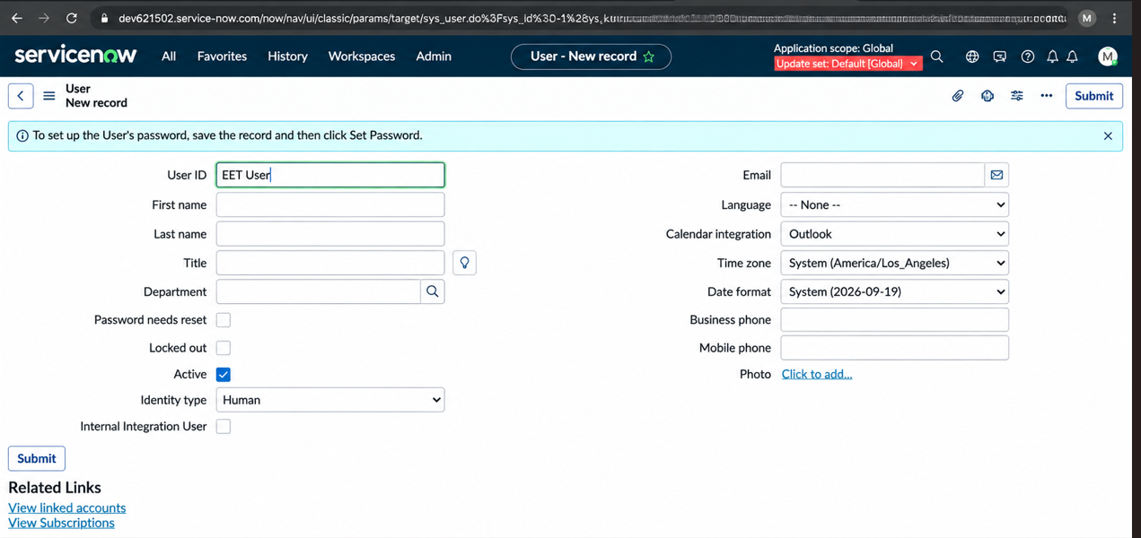

This screen demonstrates creation of the project test user used for ACL validation. The user is later evaluated against the configured role and branch-based access rules.
5.2 Table and Field Configuration
Figure 7. Institution Details Table – Complete Field Configuration
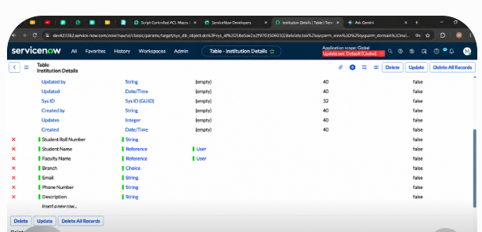

The table configuration provides the student, faculty, branch, email, phone and description fields required for the project. The Branch field is central to the Read access restriction.

5.3 Sample Records
Figure 8. Institution Details – Records Created
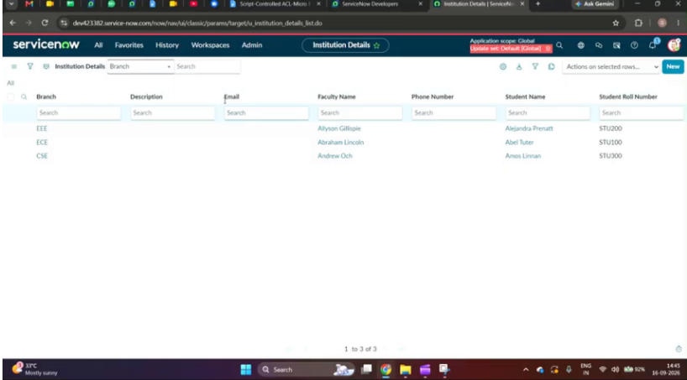

Sample records are created to represent different branch values and provide controlled data for ACL testing. The records allow EEE authorization to be compared with ECE and CSC restrictions.
5.4 Read ACL
Figure 9. Read ACL – New Record for Read Operation
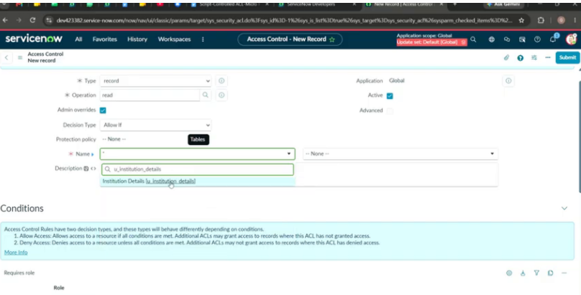

The Read ACL is created for the Institution Details table and is associated with the BB1 role. Its condition and script provide the field-based access restriction.

5.5 Script-Controlled Authorization
Figure 10. Branch Condition and Authorization Script
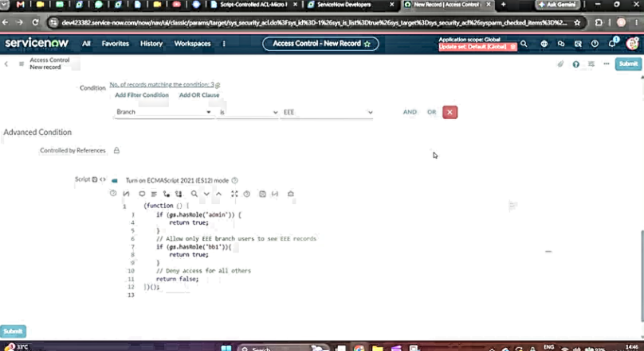

The ACL authorization section evaluates the current record's Branch value. The project rule permits the EEE branch and restricts other branch records for the configured Read user.
5.6 Create and Write ACLs
Figure 11. Write ACL Configuration
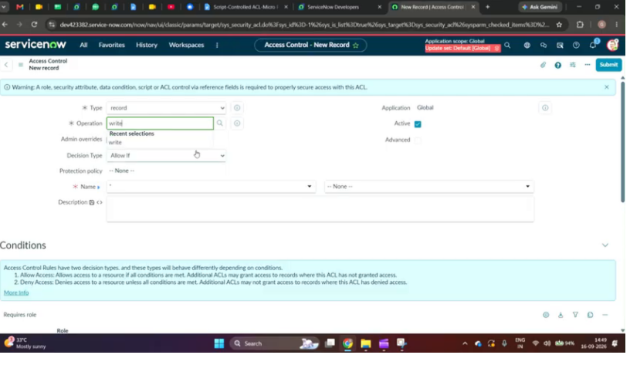

The Write ACL applies role-based authorization through BB3. It controls modification of existing Institution Details records.
5.7 ACL Verification

Figure 12. Configured ACL Rules
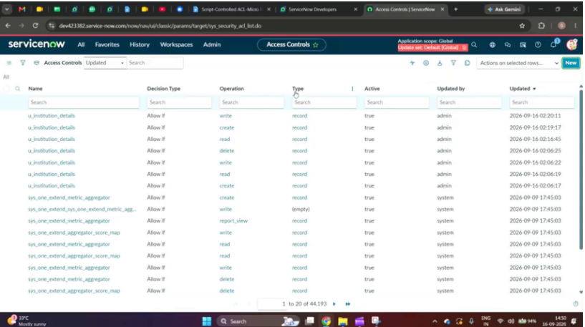

This screen verifies the configured ACL rules for the Institution Details table. The project implements separate controls for Read, Create, Write and Delete operations.
PHASE 6 – Project Testing
6.1 Test Strategy
Testing verifies configuration, role permissions, field-based Read access and operation-specific ACL behavior.
Test ID | Test | Expected Result
TC-01 | User creation | User created successfully
TC-02 | Role creation | BB1–BB4 created
TC-03 | Table configuration | Institution Details available
TC-04 | Branch choices | ECE, EEE and CSC available
TC-05 | Sample records | Test records available
TC-06 | Read – EEE | EEE record accessible
TC-07 | Read – ECE | ECE record restricted
TC-08 | Read – CSC | CSC record restricted
TC-09 | Create | BB2-controlled creation
TC-10 | Write | BB3-controlled modification
TC-11 | Delete | BB4-controlled deletion
TC-12 | Final validation | Access behavior matches requirements

6.2 Final Access Validation
Figure 14. Restricted Record Access – EEE Branch Result

The validation screen demonstrates the intended field-based behavior: the configured user can see the permitted EEE branch record. This provides evidence that the Read ACL is being applied.
Figure 15. Administrator / Role-Based Access Validation

This evidence supports comparison between restricted project-user access and broader authorized administrative visibility. It is used to confirm the final security behavior.

PHASE 7 – Project Documentation
7.1 ACL Matrix
ACL | Operation | Table | Role | Control
ACL-01 | Read | Institution Details | BB1 | Branch = EEE + script
ACL-02 | Create | Institution Details | BB2 | Role-based
ACL-03 | Write | Institution Details | BB3 | Role-based
ACL-04 | Delete | Institution Details | BB4 | Role-based
7.2 ACL Script
answer = (current.branch == 'EEE');
The script is placed in the Read ACL authorization section. It evaluates the current record's Branch value and returns true for the configured EEE value.
7.3 Documentation Package
• Final Project Report.
• User Manual.
• ACL Matrix and ACL Script.
• Update Set XML representation.
• Test Cases and Test Screenshots.
• Diagrams: Ideation, Architecture, Use Case, DFD and ER Diagram.
• Team Roles and 7-Day Project Schedule.
PHASE 8 – Project Demonstration
8.1 Demonstration Video Requirements
• Record a complete project demonstration using screen sharing.
• Include the student's voice-over/explanation.
• State the Project Name.
• Explain the Purpose and problem being addressed.
• Explain the Use/Benefits of the project.
• Demonstrate the project execution and working process.
• Show the final output and access-control result.
• Upload the completed video to Google Drive.
• Set the Drive sharing permission to Public/Anyone with the link can view.
• Submit the Google Drive demonstration link with the project.
8.2 GitHub Submission Requirements
The GitHub repository must be public and contain the project files phase-wise. A recommended structure is:
01_Brainstorming_and_Ideation/
02_Requirement_Analysis/
03_Project_Design/
04_Project_Planning/
05_Project_Development/
06_Project_Testing/
07_Project_Documentation/
08_Project_Demonstration/
README.md
8.3 Final Submission Checklist
• Public GitHub repository link is available.
• All eight phases are maintained in the repository.
• All project files/documents are uploaded.
• Final report contains the required figures and screenshots.
• Every figure has a descriptive title and two-line explanation.
• Test screenshots support the test cases.
• Demo video includes project name, purpose, benefits, working process and final output.
• Google Drive video link is set to Anyone with the link can view.
• Project Leader completes the final submission and link update.
References
1. Project Document and project requirements supplied by the training/project team (provided in the user message).
2. Project Reference Video: “Script-Controlled ACL – Restrict Record Access Based on Field Value” supplied for the project.
3. ServiceNow Developer Instance configuration and screenshots captured from the supplied project workflow.
Note: The report intentionally uses the supplied project materials as the primary references. No external technical claims are required for the implementation description.
Appendix A – Project Evidence
Implementation screenshots and diagrams are embedded in the relevant phases above. The screenshot evidence follows the project workflow from user creation and table configuration through ACL creation, script authorization and final branch-based access validation.

